Assessing Poverty in Africa, Jim Cairns.

Storyboard

Learning Objectives

Objective  (based on Bloom’s taxonomy) | Data Handling/Interpretation | Notes/ Example of Task
Knowledge | Students will be able to recognize core indicators of development from UNICEF or news agency reports and statistical or geographical data | Indicators could include access to clean water, prevalence of water-born diseases
 | Students will be able to tabulate data extracted from data sources | Create data table using 2 or more indicators from UNICEF database. Ref UNICEF database
 | Students will be able to locate areas affected by specific problems | Locate areas where access to clean water and water-based disease transmission are problems using UNICEF maps.
Comprehension | Students will be able to transform data into a several graphical formats | Use simple EXCEL software to generate graphs and charts.
 | Students will be able to describe patterns found in graphs, charts and maps | Look at Improved Drinking Water map. Which regions of Africa have most/least improved supplies?
 | Students will be able to write a short summary of an issue based on multimedia or video extract | Watch Multimedia extract Child Alert Dafur  Complete‘w’s response – what is happening, where is it, when did this happen , what is the effect, why do you think the situation arose?
Application | Students will be able classify nations according to severity of problems faced | Pick 5 indicators of development, assign them into 3 or more levels in term of severity, select 30 countries, assemble data and apply levels to cumulative data
Analysis | Students will be able to describe common patterns found in data and infer relationships between indicators | Pick two indicators from two different data sets for at least 25 countries. Construct scatter diagram to show relationship between data.  e.g. Maternal Mortality and Access to Improved Water Supply  Is there a strong correlation between the two indicators? Compare your graph with someone else’s selection. What conclusions can be drawn
Synthesis | Students will be able to draw conclusions about the causes of problems and suggest solutions | Based on above exercises, or from analysis of other news sources e.g. BBC Africa
Evaluation | Students will be able to make a broad assessment about the reliability of data and objectivity of sources | Comparison of patterns and conclusions across class.
 | Students will be able to assess the strength and weaknesses of their conclusions | Classroom or Web-based debate/ discussion on conclusions.

Targeted Learners
Middle School Students Grades 7-9

Learners’ Characteristics
Students will have some familiarity with basic African geography – locations, physical and political regions. They also may have used spreadsheet software such as Excel, although this is not essential. The web page will be fun for those students who enjoy crunching numbers as well as those who are developing social concerns about the big issues affecting other people around the world.

Sketch of Storyboard

- 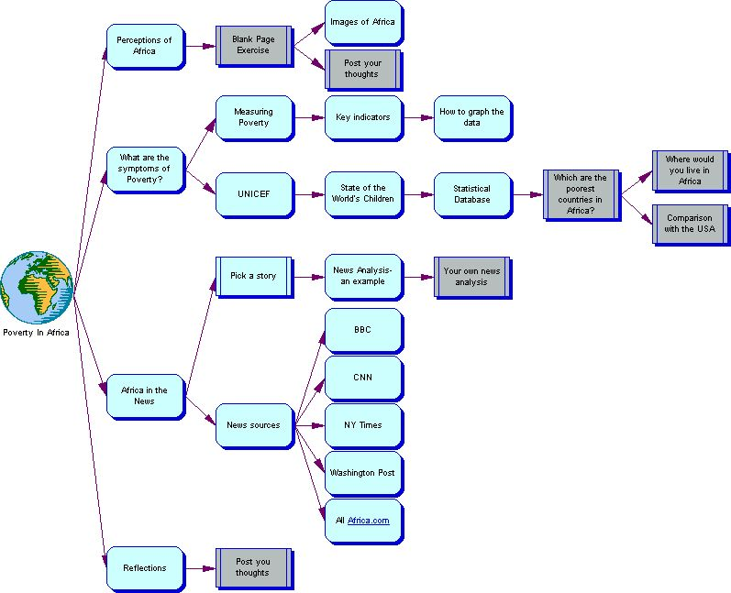

Website set up:
Homepage Assessing_Poverty_in_Africa_Homepage.html

 |  | 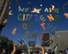
 | Assessing Poverty in Africa
Common sidebar | Introduction | Common sidebar
Links to Lessons  1. Perceptions of Africa  2. Measuring Poverty  3. UNICEF – The State of the Worlds’ Children  4. Which are the poorest countries?  5. Where would you live in Africa?  6. Reflections: Have  your perceptions changed? |  | Links to External Websites  BBC News  CNN  New York Times  All Africa. com  UNICEF  Photo Essays  Child Alert Darfur
  This website will help you:  To understand some of the issues that affect Africa and its people  To understand and process statistical evidence about those issues  To analyze current issues news stories about Africa  and…  it might…..  Change your perceptions of Africa | Most of us don’t know much about Africa  What are your perceptions of Africa?  Click on the link above to start

Assessing_Poverty_in_Africa_Perceptions.html

 | Assessing Poverty in Africa
Common sidebar | Lesson 1 Perceptions of Africa | Common sidebar
Links to Lessons  1. Perceptions of Africa  2. Measuring Poverty  3. UNICEF – The State of the Worlds’ Children  4. Which are the poorest countries?  5. Where would you live in Africa?  6. Reflections: Have  your perceptions changed? | Most people don’t know a great deal about Africa  Find yourself a quiet corner and think about the three topics below.  Write down 10 different words or phrases that describe what you know or how you feel about each.  IMPORTANT ! SAVE YOUR THOUGHTS AS A WORD DOCUMENT  Now click on the links below and write down 4-5 phrases that describe your reaction to the images you see.  UNICEF Photo essay  AGAIN – DON”T FORGET TO SAVE YOUR THOUGHTS AS A WORD DOCUMENT | Links to External Websites  BBC News  CNN  New York Times  All Africa. com  UNICEF  Photo Essays  Child Alert Darfur
  African People | The Best Things about Africa | The Worst Things about Africa

Assessing_Poverty_in_Africa_Measuring_Poverty.html

 | Assessing Poverty in Africa
Common sidebar | Lesson 2.1 Measuring Poverty |  |  | Common sidebar
Links to Lessons  1. Perceptions of Africa  2. Measuring Poverty  3. UNICEF – The State of the Worlds’ Children  4. Which are the poorest countries?  5. Where would you live in Africa?  6. Reflections: Have  your perceptions changed? | If we are going to assess a whole country then we need lots of data – statistics to get the whole picture.  Let’s go on and look at the sorts of statistics that are available. CLICK HERE TO MOVE ON!  Assessing_Poverty_in_Africa_Measures_of_Poverty.html |  |  | Links to External Websites  BBC News  CNN  New York Times  All Africa. com  UNICEF  Photo Essays  Child Alert Darfur
  Assessing the patient!  If we are going to assess poverty levels in Africa we need to think about taking some measurements. Let’s consider how a doctor might look at a patient  Vital signs  Body temperature  Blood pressure  Pulse  Breathing  Symptoms of illness  Fever  High or low blood pressure  Erratic pulse  Irregular breathing  Rashes, bleeding etc | Assessing a country  The vital signs of a country are the things that tell us how ‘fit’ it is. A country that is suffering from poverty will have symptoms of its condition.    Vital signs  Economy  Health  Social Conditions  Education  Politics    Symptoms of something wrong  Little produced of value  Low life expectancy  High infant mortality  Disease/Disaster  Unemployment  War/Civil unrest
 | Assessing Poverty in Africa
Common sidebar | Lesson 2.2 Measures of Poverty |  |  | Common sidebar
Links to Lessons  1. Perceptions of Africa  2. Measuring Poverty  3. UNICEF – The State of the Worlds’ Children  4. Which are the poorest countries?  5. Where would you live in Africa?  6. Reflections: Have  your perceptions changed? | UNICEF –collects huge amounts of statistics and its website helps to you to create your own data sets.  Have a look at the UNICEF web site. Click on the following link UNICEF Statistics and follow the instructions  CAN YOU CREATE A TABLE SIMILAR TO THIS? Try it using your own selection of data and countries  Notice the blue link this tells you what the data represents |  |  | Links to External Websites  BBC News  CNN  New York Times  All Africa. com  UNICEF  Photo Essays  Child Alert Darfur
  Here are a couple of standard statistical measures used when we assess a country.
  Economic Measures: GNI per capita– Gross National Income per person– a measure of average income
  Health Life expectancy – a basic measure of how long most people live
  Infant mortality –probability of dying before your 1st or 5th birthday –expressed as number out of 1000
  THERE A LOTS MORE!
   | Infant mortality rate (under 1) (2004) ^{I-1} ^{I-2} | Life expectancy at birth (years) (2004) ^{I-3} ^{I-4} | GNI per capita (US$), 2004 ^{I-5} ^{I-6}
  Nigeria | 101 | 43 | 390
  Sierra Leone | 165 | 41 | 200
  Uganda | 80 | 48 | 270
  United Kingdom | 5 | 79 | 33940
  United States | 7 | 78 | 41400
 |  | Assessing Poverty in Africa
Common sidebar |  | UNICEF – The State of the Worlds’ Children | Common sidebar
Links to Lessons  1. Perceptions of Africa  2. Measuring Poverty  3. UNICEF – The State of the Worlds’ Children  4. Which are the poorest countries?  5. Where would you live in Africa?  6. Reflections: Have  your perceptions changed? |  |  | Links to External Websites  BBC News  CNN  New York Times  All Africa. com  UNICEF  Photo Essays  Child Alert Darfur
  Statistics: Data and Tables/Charts  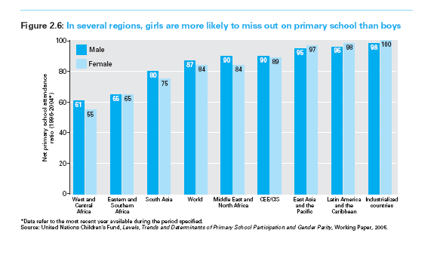What are some of the patterns you notice in these charts? Where does Africa fair on them? | Profiles – Excluded and Invisible Children –  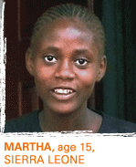  The stories of 8 children  representing millions around the world.  What are some of the problems facing Martha and Keabetswe?
  The Millenium Goals ( includes some interesting videos)    What are the goals to end poverty? |   This is a disturbing report on the situation in Darfur – a region which has suffered from over three years of war and civil strife.  Take you time to look through this report and then reflect on the following question.  What can be done to help children in Darfur?

Assessing_Poverty_in_Africa_UNICEF.html

Video Storyboard: Keabetswe’s Story
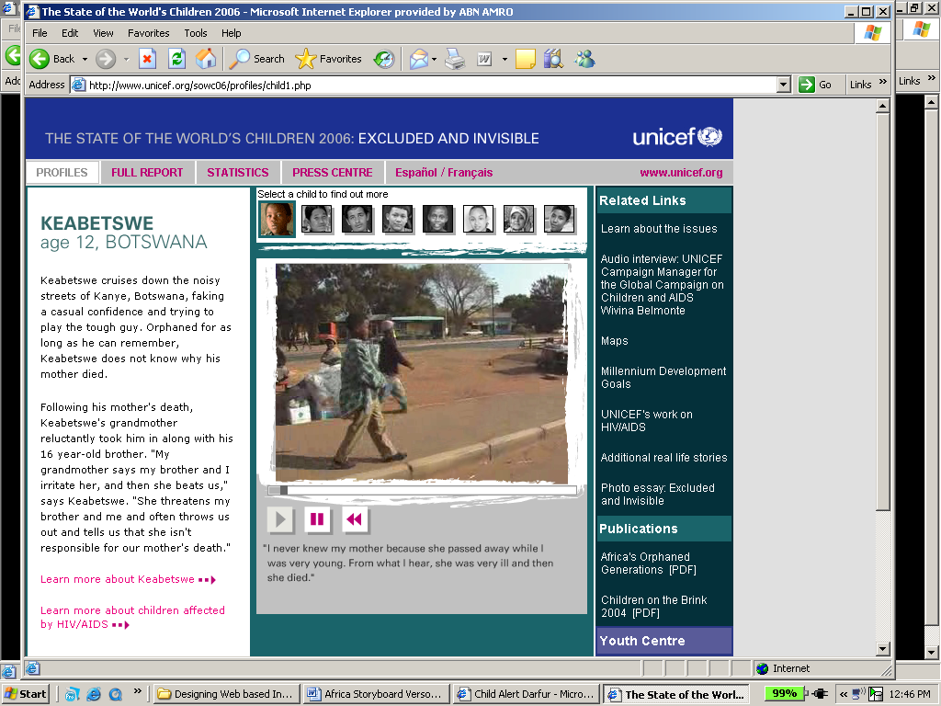

Keabetswe is one of the two African children featured in the State of the World’s Children 2006 report. My web site provides a link to the two stories.

The stories are set out a streaming video with audio commentary – in the child’s own words.

The video is supported by written biographical details – useful for students to print out and read.

Other children’s stories can be accessed via the picture-menu above the video frame.

The next page shows an analysis of the streaming video.

Video Storyboard: Keabetswe’s Story
Scene | Dialogue (overdubbed English) with background level sound of K’s voice | Video/Audio Technique- comments – all transitions appear to be cut-aways
Keabetswe walking along sidewalk of busy street | My name is Keabetswe Harbutre. I am 12 yrs old. I live in Kanye. Botswana. | Medium shot  Camera tracks along street with child
Head and shoulder close up of ‘K’ talking | I live with my grandmother, but I don’t like living with her. | Close up
‘K’ walking towards camera in front of shop/store | She used to threaten my brothers and me and told us that it wasn’t her fault that our mother was dead. | Long-shot-medium shot
‘K’ lifting shirt to show scars from beating | And she used to beat me up brutally | Medium shot then zooms in to ‘K’s back
‘K’ sitting on curb, view of adult’s legs immediately behind and other people in background | I never knew my mother because she passed away while I was very young | Placing subject against legs of adult emphasizes his young age and stature  Medium shot
‘K’ walking towards camera in front of another store | From what I hear, she was very ill and then she died. | Long shot
K turns and points at store | One day I was with my friend who was stealing some sweets. My friend put the sweets in his jacket | Medium shot
K walking behind clothing rack in store | and the shop owner started to beat us | Camera zooms into K’s face
K walking along gulley/wasteground away from camera, swings across to separate group of other children walking in same direction | My life has improved a lot since I came to this project. We come here in the morning have breakfast | Long shot – camera pans left to catch other children
K and other children sitting on bench eating | We come here in the morning have breakfast | Medium shot of 3-4 children then zooms into K’s plate and him eating
Close-up of teacher, then K reciting something, then pair of boys working | and then go to school. | Medium shot from back over right shoulder, close-ups of K and boys
K sitting on bench between 2 adults – man and woman. Woman ( grandmother?) stroking K’s head | I am happy here with these people but the problem is that I have to go home. I don’t like that. | Wide shot of all 3 on bench, zoom into K’s head being stroked and further zoom into K’s (unhappy) face
Switch to UNICEF graphic – flash sequence  Blue background, white text | No dialog  Flash sequence of phrases – UNICEF  “For every child – health, education, equality, protection”  Advance Humanity -UNICEF LOGO | Background sounds of children singing

Video Storyboard: Child Alert Darfur

The UNICEF site is divided into a number of sections providing different materials relating the situation.

- A PDF version on the report
- A flash video – a photo essay - analyzed below
- Details of UNICEF’s work in the region
- The historical and geographical aspects of the conflict

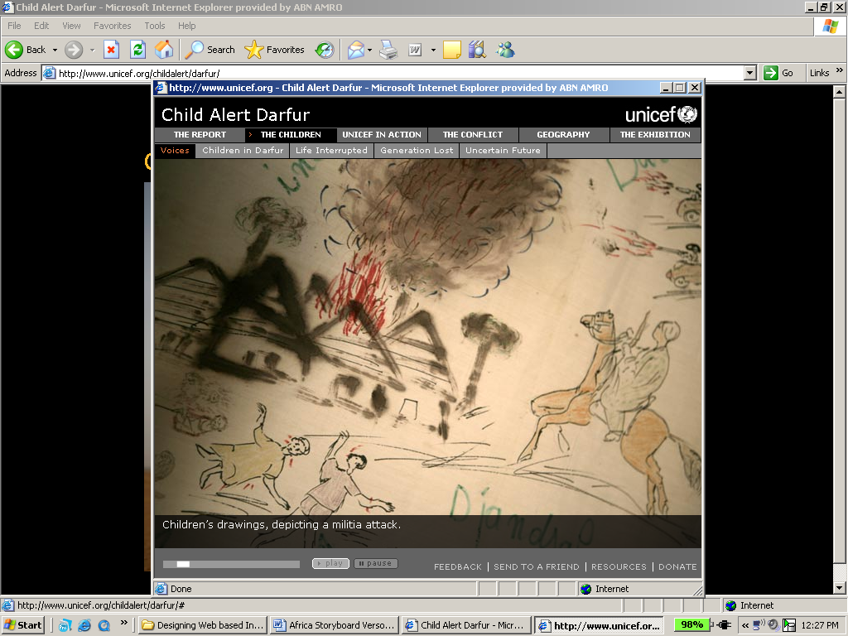
My site simply provides a link to this

The menu bar at the top of the screen allows navigation through each section
The ‘play-pause’ function allows viewers to set their own pace.

Below is an analysis of the media elements contained therein.

Flash Video duration: 5mins

Video Storyboard: Child Alert Darfur

Scene | Dialogue | Video/Audio Technique
Opening still image  3 young women facing camera  Download link – printed report or flash | none | Single image on black background
Opening page –contains links to 5 sections  Voices – Children in Darfur-Life Interupted- Generation lost – Uncertain future |  | Sequential still images with audio commentary – photo essay
Voices – opening sequence | Recording of eye witnesses and victims  Introduction by Ron Aviv  “I was asked by UNICEF to go to Darfur to photgraph and document the life of children and the effect the civil war was having.” | Still images – opens with children’s drawings on wall depicting a militia attack  Fades through to photographs of variety of scenes  Each image has subtitles – extracts from audio commentary
Children in Darfur, Life Interrupted, Generation Lost Uncertain Future | Commentary from Ron Aviv and sound bites from Darfur inhabitants | Images fading through as above  Sound bites included background ‘environmental’ sounds – birds, wind through trees, vhf-radio chatter, helicopters – each matched to image
 | Example of images and appropriate sounds and commentary
Generation lost | “Women and girls in their daily search for firewood are often attacked and raped” | 3 images quickly (5 seconds) fading  - Image of girl running across dry scrub landscape  - 2 girls carrying water – close up  - 3 girls wearing half veils- girl in foreground in focus, others blurred  Ron Aviv commentary, background sound of wind and a single bird call

Assessing_Poverty_in_Africa_Poorest_Countries.html
 | Assessing Poverty in Africa
Common sidebar | Which are the poorest countries in Africa? | Common sidebar
Links to Lessons  1. Perceptions of Africa  2. Measuring Poverty  3. UNICEF – The State of the Worlds’ Children  4. Which are the poorest countries?  5. Where would you live in Africa?  6. Reflections: Have  your perceptions changed? | Your next job is to answer the question  Which are the poorest countries in Africa?  However you have to support your answer with statistical data and graphs.  Here’s how to do it!  - Go back to the UNICEF database – find customized statistical tables (click here for link)  - Select all 55 African countries (note you need to use CNTRL button to select more than one)  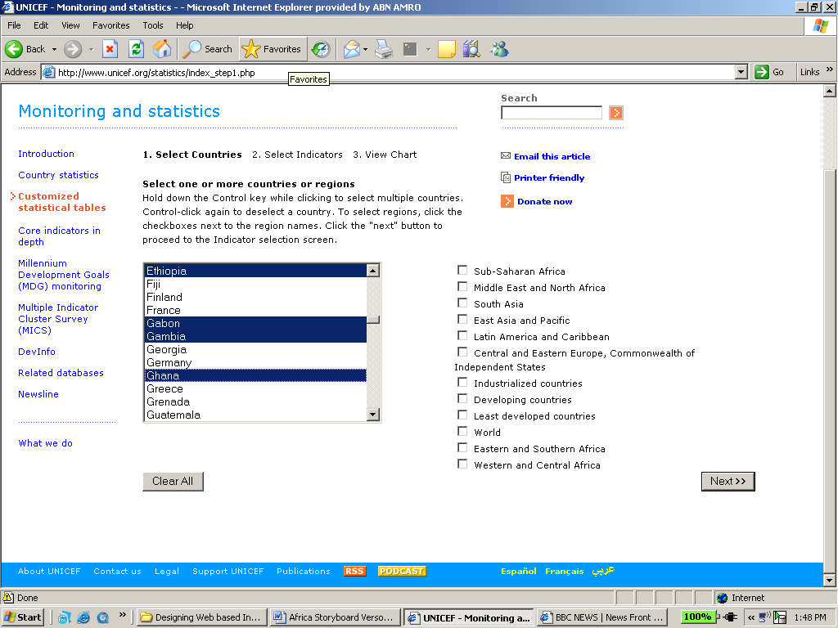  - Pick 5 key measures or indicators of development.  NB You need to add each indicator to your list and you may need to step back and forth to the pages to get your list in shape. Remember there a lot of indicators to choose from  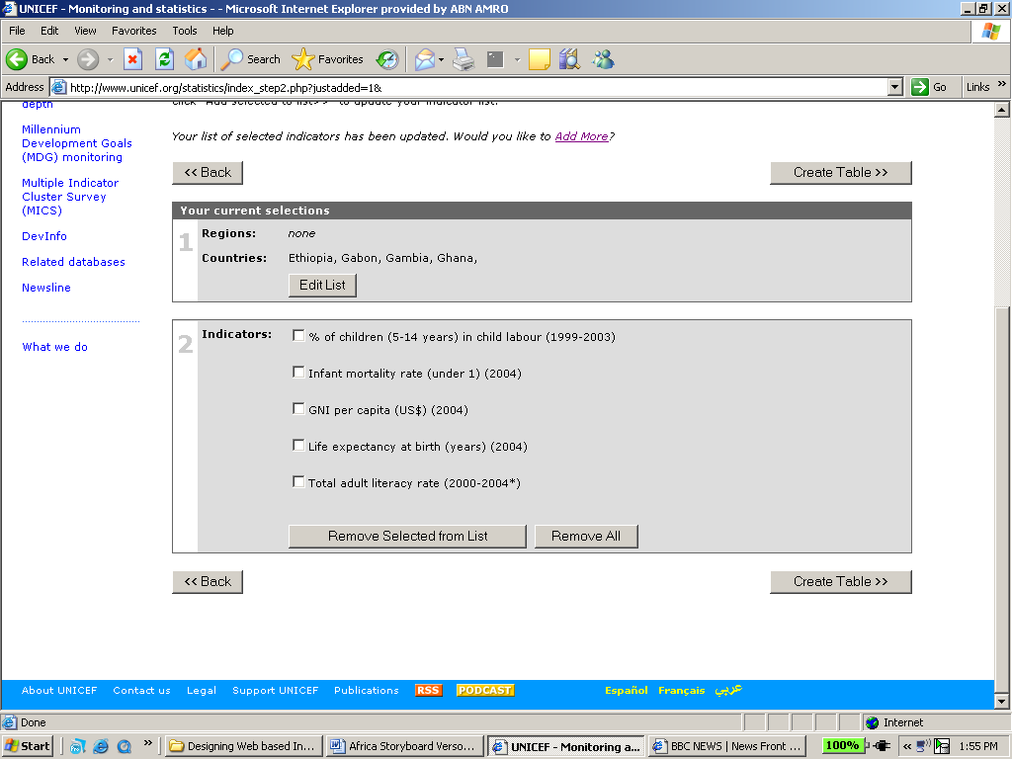  - Create a table – it should look something like the example below  Sometimes you will find that several countries have missing data. If that happens try another indicator until you get better coverage.  - Export the data into an Excel Spreadsheet. – SAVE IT as a separate document. At this stage it is easier to cut and paste the Indicator Notes into a separate document for later use.  - Here’s a simple version of a table.  - You can do a number of things with the data.  - You can graph it – see example below  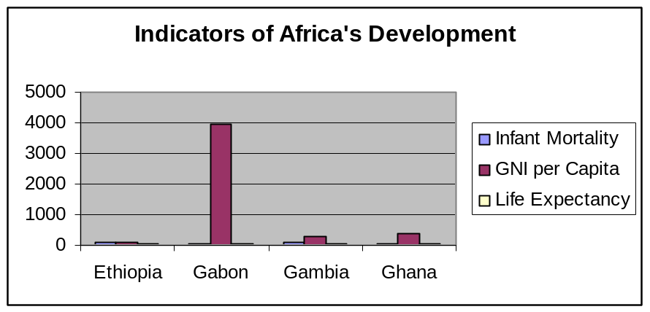  - You might find that some countries consistently come out worse than others. Have a look at your data – are there some countries that look bad to you?  - Another alternative is to try a Ranking Analysis.  - Look at the table above. We have added extra columns to show the ranking of each country for each of the indicators. You need to remember how you are ranking – is a high infant mortality figure good or bad – clearly it’s bad. Work on a ‘worst is last” principle and you won’t go far wrong  - The last column shows the average (mean) rank. In the example we’ve got here Ethiopia clearly comes out as the worst of the four countries – not surprisingly – life expectancy is only 48, you have an 11% chance of dying before you reach your first birthday and it has the lowest GNI of the lot.  CHALLENGE ACTIVITY  There are several methods of figuring out which country is the poorest.  Try the following:  - Scatter diagrams – plot pairs of indicators on a series of scatter diagrams – do certain countries regularly come out at the poor end of the diagram?  - Check out the United Nations Human Development Reports – the website has some very useful statistics on the overall patterns of development – including a ranking for the UN Human Development Index (HDI) – a summative statistic measuring overall development . Does your ranking tell the same story as the HDI? | Links to External Websites  BBC News  CNN  New York Times  All Africa. com  UNICEF  Photo Essays  Child Alert Darfur
   | % of children (5-14 years) in child labour (1999-2003) ^{I-1} ^{I-2} | Infant mortality rate (under 1) (2004) ^{I-3} ^{I-4} | GNI per capita (US$) (2004) ^{I-5} ^{I-6} | Life expectancy at birth (years) (2004) ^{I-7} ^{I-8} | Total adult literacy rate (2000-2004*) ^{I-9} ^{I-10}
  Ethiopia | 43 ^{D-1} | 110 | 110 | 48 | 42
  Gabon | - | 60 | 3940 | 54 | -
  Gambia | 22 | 89 | 290 | 56 | -
  Ghana | 57 ^{D-1} | 68 | 380 | 57
   | Infant mortality rate (under 1) (2004) I-3 I-4 | GNI per capita (US$) (2004) I-5 I-6 | Life expectancy at birth (years) (2004) I-7 I-8
  Ethiopia | 110 | 110 | 48
  Gabon | 60 | 3940 | 54
  Gambia | 89 | 290 | 56
  Ghana | 68 | 380 | 57
   | Infant mortality rate (under 1) (2004) I-3 I-4 | Rank  (worst is last!) | GNI per capita (US$) (2004) I-5 I-6 | Rank  (worst is last) | Life expectancy at birth (years) (2004) I-7 I-8 | Rank  (worst is last) | Overall  (Mean)  Rank
  Ethiopia | 110 | 4 | 110 | 4 | 48 | 4 | 4
  Gabon | 60 | 1 | 3940 | 1 | 54 | 3 | 1.66
  Gambia | 89 | 3 | 290 | 3 | 56 | 2 | 2.66
  Ghana | 68 | 2 | 380 | 2 | 57 | 1 | 1.66

Assessing_Poverty_in_Africa_Where_would_you_live?.html
 | Assessing Poverty in Africa
Common sidebar | Where would you live in Africa? | Common sidebar
Links to Lessons  1. Perceptions of Africa  2. Measuring Poverty  3. UNICEF – The State of the Worlds’ Children  4. Which are the poorest countries?  5. Where would you live in Africa?  6. Reflections: Have  your perceptions changed? | You’ve now managed to figure out which countries are the poorest on the Africa continent, and probably have some idea of the reasons why they are in such a state. You probably also have an idea of the countries that appear at the wealthy end of the rankings.  Now you need to make another decision.  WHERE WOULD YOU LIVE IN AFRICA?  – which country would you choose?  To do this – you need to look at the following news links  - BBC news - the Africa section and country profiles BBC NEWS | Country Profiles  - Allafrica.com/ - a news source from Africa  - CNN's Africa section  - The New York Times -Africa section  - Africa.Net – a news and information source  Look through the various stories and news sections.  - What factors would be important to you in choosing a country? – e.g health, landscape etc.  - List the factors that would be important to you.  - Explain of how your chosen country meets the factors mentioned above | Links to External Websites  BBC News  CNN  New York Times  All Africa. com  Africa.Net  UNICEF  Photo Essays  Child Alert Darfur

Assessing_Poverty_in_Africa_Changed_Perceptions?.html
 | Assessing Poverty in Africa
Common sidebar | Reflections: Have your perceptions changed? | Common sidebar
Links to Lessons  1. Perceptions of Africa  2. Measuring Poverty  3. UNICEF – The State of the Worlds’ Children  4. Which are the poorest countries?  5. Where would you live in Africa?  6. Reflections: Have  your perceptions changed? | You will remember that the very first task we asked you to perform was the following  Write down 10 different words or phrases that describe what you know or how you feel about each.  You then looked at the UNICEF Photo essay  and wrote down 4-5 phrases that described your reaction to the images you saw  Look back at your documents.  How have your perceptions changed?  Do you think your knowledge and perceptions are more accurate now than before?  Are there any lingering questions that you would like to investigate regarding Africa? | Links to External Websites  BBC News  CNN  New York Times  All Africa. com  UNICEF  Photo Essays  Child Alert Darfur
  African People | The Best Things about Africa | The Worst Things about Africa

Assessing_Poverty_in_Africa_Changed_Feedback.html
 | Assessing Poverty in Africa
Common sidebar | Feedback | Common sidebar
Links to Lessons  1. Perceptions of Africa  2. Measuring Poverty  3. UNICEF – The State of the Worlds’ Children  4. Which are the poorest countries?  5. Where would you live in Africa?  6. Reflections: Have  your perceptions changed? | It would useful for us if you could complete the following feedback form.  These buttons would record choices. The intention is to record data (off-site) and adjust website accordingly in response. | Links to External Websites  BBC News  CNN  New York Times  All Africa. com  UNICEF  Photo Essays  Child Alert Darfur
  Which sections of the website proved.. | Most useful | Easiest to use | Hardest to use
  1. Perceptions of Africa
  2. Measuring Poverty
  3. UNICEF
  4. Which are the poorest countries?
  5. Where would you live in Africa?
  6. Reflections: Have you perceptions changed?

