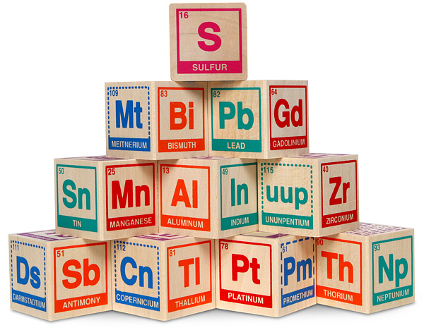
You are now the proud parent of an element baby! Congratulations on your new responsibility. Being a parent can be tough...you really need to understand your element baby, so that you know how to take care of it. Is your baby radioactive? Should you be wearing a protective suit? Is your baby a gas at room temperature? Maybe it needs to be kept in a special container, so it doesn't get away! Maybe your baby is highly reactive! If you know, you can find out what other elements to keep your baby away from.

Directions:
Fill out your Adoption Papers for your element. Then create a presentation (powerpoint, slides, or prezi) that has the information for #1, 2, 3, 4, 5, 12, 13, 14, 22, 23, & 24 on the adoption paper and a picture of your element. You can add more if you chose to do so. Create a correct work cited slide, remember use cite this for me to help you out.
Practice your presentation! Be aware of your voice volume and tone (no one wants to listen to a monotone voice). Watch yourself in a mirror so that you do not fidget or sway. Know your information so you are not looking at the presentation the entire time. Give the audience eye contact and SMILE!!)

You may go beyond these requirements to earn EXTRA CREDIT. In order to get the extra credit you do have to have completed your adoption papers. You may write an original song, story, cartoon, joke or poem about your element, create a game, and/or include research about the scientist who discovered your element in your presentation.

Please use the following links to help you fill out your adoption papers. DO NOT USE WIKIPEDIA!!!
Research Links:
http://www.chemicool.com/
http://www.webelements.com/atoms.html
http://education.jlab.org/itselemental/
http://chemistry.about.com/library/blperiodictable.htm
http://www.periodictable.com/
http://www.ptable.com/
http://www.infoplease.com/periodictable.php
http://www.rsc.org/periodic-table/
http://chemmac1.usc.edu/java/ptable/ptable.html
http://www.colorado.edu/physics/2000/applets/a2.html
http://theodoregray.com/periodictable/
http://www.chemicalelements.com/show/name.html
Web Elements
Chemicool
Los Alamos Periodic Table
Visual Elements
Lenntech Periodic Table
It's Elemental Table
Chemical Elements
Bayer Periodic Table
Chemical Comics
MII Periodic Table

