|  |  |  |  |  |
| --- | --- | --- | --- | --- |
|  |  | |  | | --- | | Great Falls Elementary…  News You Can Use! | | October  2017 | |
|  |  |  |
| October 2017 |  |  |



A Note from the Principal

Great Falls Elementary is such an amazing place to learn and grow…both as a student and as a professional. I am thrilled to be a part of such a wonderful school family. While academic success is our priority and is expected of our students, at GFE we believe in the total development of the whole child. Therefore, it is equally important for us to provide extracurricular activities to our students, as well. Participation in student organizations, academic clubs, and other extracurricular clubs allows students to develop leadership, communication, critical thinking skills, and civic responsibilities that are essential to be successful in a 21st Century Learning Environment in this global society. This approach to learning will develop leadership capacity and scholarship in students that will prepare them for our elementary setting and far beyond. I am proud to serve a very diverse and interesting student population who are the young leaders of this wonderful Great Falls community.

In addition to being proud to serve this magnificent host of students, I am equally honored to be the leader of such a talented and committed staff. I have worked in many different settings over the course of my career, and I can honestly say that I have never worked with a more dedicated and competent staff of people. These folks go the extra mile each day and are committed to reaching every child

Humbly,

Tammy Smith Taylor



Oct. 9-13: Fire Prevention Week

Oct. 9: Teacher Work Day – no school for students

Oct. 10: 1st and 2nd Grades Math & Science Night, 6:00

Oct. 10: SIC/PTO Meeting 5:00-7:30 pm

Oct. 16: School Board Meeting

Oct. 23-27 Red Ribbon Week

Oct. 24: Report Cards issued

Oct. 26: Awards Program

Oct. 31: 5th grade trip to Career County Career Center

**\*\*\*Coming Up in November\*\*\***

Nov. 3 Fall Carnival 6:00-9:00

Nov. 6-10: Scholastic Book Fair

**Character Word of the Month**

**Dignity-** (Noun)

To be worthy of a way of appearing or behaving that suggest seriousness and **self-control.**

**Example**: She showed her true ***dignity*** when under pressure.

.

​



**1st and 2nd Grades**

**Family Math and Science Night**

**GFE Cafeteria, 6:00 pm**



**“Your Future is Key-Stay Drug Free”**

**Monday**: “Drugs Are Old School” – wear 70’s attire

**Tuesday**: “Be a Rock Star-Stay Drug Free” – wear Rock and Roll attire

**Wednesday**: “Arm Up Against Drugs” – wear camouflage/Army attire

**Thursday**: “Be a Super Hero and Stay Drug Free” – wear super hero attire

**Friday**: “Show Good Character Against Drugs” – Dress up as your favorite book character



The PTO is always looking for volunteers! If you would like to serve or simply join the PTO, please contact the school office at 482-2214 so they can let the PTO parent volunteer coordinator know!

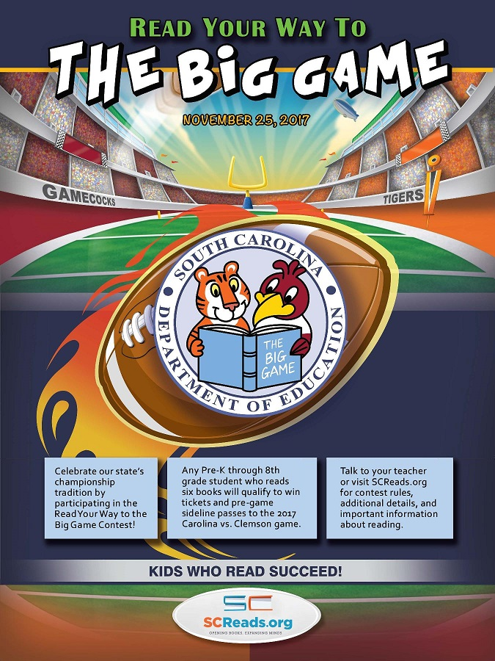



Now that we are back in school, remember to practice GOOD HANDWASHING to prevent the spread of germs!

All prescription medication needs a doctor’s order. The form can be picked up from the nurse or the front office secretary. Prescription medicines CANNOT be given WITHOUT a doctor’s order form!!  All over-the-counter medications have a form which the parent must sign in my clinic, and they must be brought in the original bottle.

Remember that if your child has a fever of 100 degrees or more, it is the school district’s policy that your child may not return to school until he or she is fever free for 24 hours **without the use of any fever reducing medications!**

If your child throws up at school, they **may not** return to school for **24 hours.**



Don’t forget to turn in your box tops!

We collect them all year long!





In an effort to make it easier for you to manage your student(s) lunch accounts, you may now pay their account online. All you need to do is go to [**www.k12paymentcenter.com**](http://www.k12paymentcenter.com). You may also send it to school in an **envelope marked with the student’s name**. Please be advised that students who have an account balance will not be allowed to receive the lunch that is on the menu. They will receive a peanut butter sandwich and will still be charged for the meal. If you have a balance, you may contact Mary Case in the cafeteria to set up a payment plan.

**2015-2016 Cafeteria Prices**

Breakfast Lunch

Student $1.00 Student $1.75

Reduced $0.30 Reduced $0.40

Adults $2.10 Adults $3.50

Milk $0.50 Milk $0.50

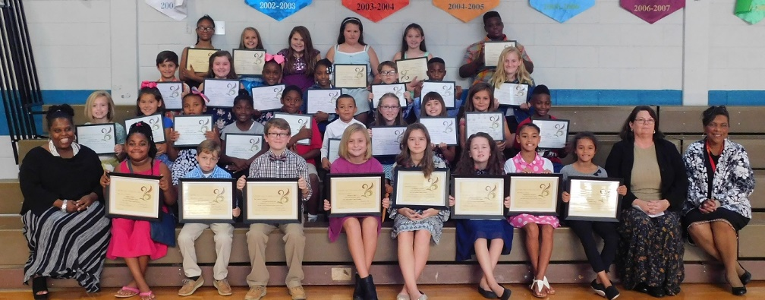

2017-2018 Student Council Officers and Representatives

Officers: Jordyn Price, Kaden Hudson, Jackson Kennington (former president), Kinsley Price, Kameron Cooper, Angelina Brooks, Deseraye Coleman, Chloe Davis,

Mrs. Taylor, Ms. Chase, Mrs. Washington-Kelly.

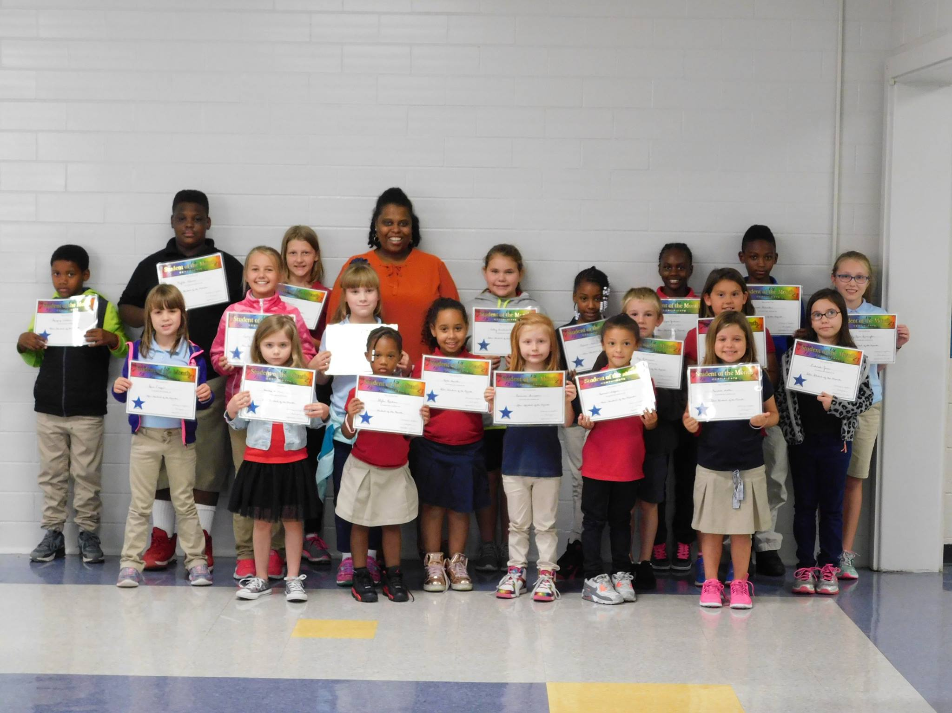

September STAR Students of the Month

Gregory Weldon, Mylik Adams, Dacoda Jamaca, Mrs. Taylor, Abigail Funderburk, Keiana Hall, Ja’Niyaa Jackson, Israel Gladden, Lily Grace Kennington, Sara Capps, Laney Funderburk, Makenzie Messer, Bella Levister, Arianna Thompson, Keonna Talford, Coy Robinson, Chloe Sistare, Deborah Jones, Harley Dutton, Skylar Roseboro, Kendall Trotter.