Budget Beef Bourguignon: Succulent Beef Stewed in Merlot
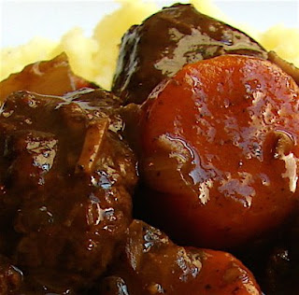 Beef Bourguignon is beef braised in Burgundy wine. It is delicious. Follow the recipe below.
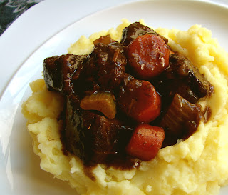
Ingredients:
2 tbsp vegetable oil
2 1/2 lbs beef chuck roast, cut in 2-inch cubes
salt and fresh ground black pepper to taste
1 onion, chopped
1 tbsp butter
2 tbsp flour
2 carrots, cut in 1-inch pieces
2 ribs celery, cut in 1/2-inch pieces
1 bay leaf
4 springs fresh thyme
2 cups merlot, or other red wine
2 cups beef broth
2 cups of mashed potatoes Save

