5 Fundamental Traits of a Good Wine

1. Acidity
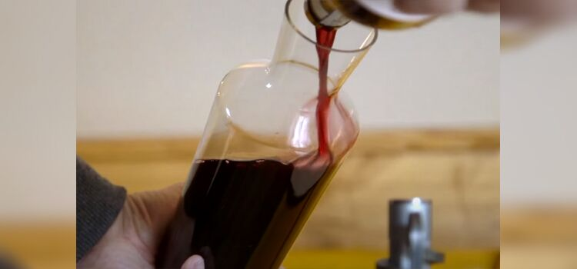
Acidity is a key characteristic of wine that refers to tartness or sourness [1].
High-acidity wines have a crisp, refreshing taste that can cut through rich or fatty foods and make the wine feel more vibrant on the palate.
The acidity level varies depending on the type of grape used and the winemaking process.

2. Alcohol Content
The alcohol content of wine refers to the percentage of ethanol in the wine. It can range from 5% to 20%, with most wines falling between 12% to 14%.
The alcohol content affects the flavor and body of the wine, with higher-alcohol wines often having a fuller body and richer flavor profile.

3. Body
The body of wine refers to its weight and texture on the palate.
It can be described as light, medium, or full-bodied. Light-bodied wines feel thin and watery, while full-bodied wines feel rich and heavy.
The body is influenced by the alcohol content, tannins, grape variety, and winemaking techniques.

4. Sweetness
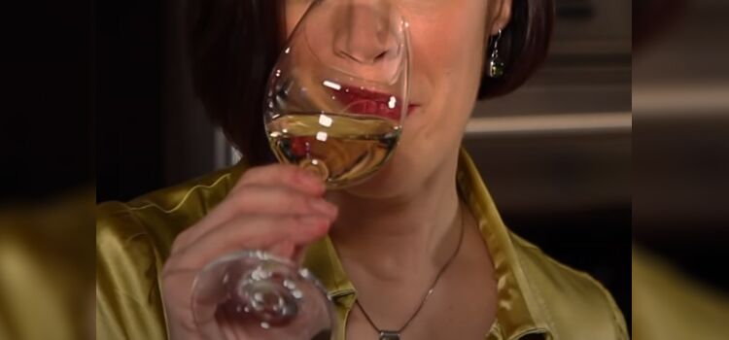
Sweetness in wine refers to the amount of residual sugar left after fermentation.
Sweet wines have a higher sugar content and are often described as having a fruity or dessert-like taste.
Sweetness levels can vary from bone-dry to extremely sweet and can be balanced by acidity.

5. Tannin
Tannins are naturally occurring compounds found in grape skins, seeds, or the whole berry [2] that give a bitter or astringent taste and a drying sensation in the mouth.
Tannins are more prominent in red wines than white wines and provide structure and aging potential.

FAQs
What should a beginner know about wine?
A beginner should at least know the four main types of wine: white, red, rose, and sparkling wines, apart from dessert and fortified wines.
How do you tell good wine by the bottle?
It is difficult to determine a great wine based solely on its bottle. However, the label can provide some valuable information about the wine.
The best way to know the quality of a wine is by tasting it.
How do you choose a good wine for dinner?
You should consider the meal’s flavors and select a wine that complements or contrasts them.
In any case, go for the wine from the same region where your dinner is. If you’re in Napa Valley, order the wine made in that particular area.

In A Nutshell
Choosing a good bottle of wine involves considering many factors, such as your taste preferences, the wine’s label and information, the occasion, and more.
You can refer to our guide above or seek advice from a wine specialist to learn more about choosing wines that suit your preferences.
References:
- https://waterhouse.ucdavis.edu/whats-in-wine/fixed-acidity
- https://www.extension.iastate.edu/wine/lets-focus-dr-watrelot-1/
Pat Strunk
Pat is our resident expert when it comes to bourbon and traveling. His impeccable writing skills and sales background are perfect for his copywriting specialization. He’s a brand storyteller who has worked for the biggest retail brands and business personalities.
When he goes out to relax or celebrate some small wins, Pat never ceases to grab a bottle of Buffalo Trace. For him, this classic Kentucky bourbon whiskey is perfect for slow sipping. Contact at pat@liquorlaboratory.com or learn more about us here.
CategoriesWine
7 Best Alcohols For No Hangover: Full Guide (2023)
What Is A Draft Beer? Answered (2023 Updated)

