How To Choose A Good Wine: Full Guide (2023 Updated)
March 13, 2023, 10:52 pm by Pat Strunk
Last Updated on April 9, 2023, by Lydia Martin
Are you overwhelmed just by staring at a wall of wine bottles, unsure where to start with your wine shopping?
If you’re just starting out with your wine journey, choosing wines can be daunting. However, it doesn’t have to be.
To steer you in the right direction, we’ve rounded up ten tips on how to choose a good wine to make your life easier, including the five fundamental traits of what makes the best wine.

10 Tips To Choose A Good Bottle of Wine

1. Start With A White Wine Or Rose
White or rose wines are always a great starting point since they have a lighter, sweeter, and more refreshing flavor profile than red wines.
They’ll make it easier for you to appreciate and enjoy wines without being completely overwhelmed by complex flavors and tannins.
A sweeter wine often delivers good first impressions on beginners’ wine viewpoints.
But, if a sweet wine like white and rose makes you cringe, you can opt for their dry wine counterparts.

2. Choose Quality Over Price Point
An expensive wine may be overpriced due to its rarity, prestige, or even luxurious cachet design, but that’s not always a guarantee of quality.
In fact, many affordable, high-quality wines in the market could be more delicious and offer more excellent value for money than expensive wines.
Ultimately, wine doesn’t need to be expensive when you’re only starting out in the wine world.

3. Use Your Taste Preferences
Your taste preferences are critical in choosing a good bottle of wine because everyone’s taste buds are unique, as what may be a great wine for one person may not be as enjoyable for another.
For instance, if you enjoy black coffee or grapefruit juice, you may appreciate an acidic wine like Pinot Noir.
On the other hand, if you prefer apple juice or other drinks that pack sweetness, you may enjoy a sweet white wine.
It’s essential to consider your taste preferences as this can help you find a wine that you’ll genuinely enjoy.

4. Read The Label & Focus On The Wine Information
The label and information on the wine bottle can provide valuable insight into the wine’s origin, grape variety, and winemaking techniques, helping you make a more informed decision and select a likely enjoyable and high-quality wine.
Tip: One key information to look for is whether the particular wine is estate bottled. This label means that the wine has been produced entirely from grapes grown on the winery’s estate and has been appropriately bottled.

5. Carefully Choose A Wine Label

First Label
The first label also referred to as the “flagship label,” is vital because it signifies that the wine is typically reserved for the winery’s top-of-the-line wines.
These wines are made from the winery’s best grapes, with careful aging, and crafted with great attention to detail.

Second Label
The second label is also an important factor because it is typically used for wines that are still high-quality but may not meet the same standards as the first-label wines.
These wines may be slightly inferior in all aspects compared to the first-label wines.

6. Don’t Focus On The Wine’s Age
Some wines are meant to be consumed young and fresh, while others can benefit from undergoing the aging process.
Focusing solely on the age of wine can lead to the common misconception that older wines are always better, which is not necessarily the case.
While the age of wine can be an important indicator, you should instead focus on the wine’s grape variety, the region it is made, vintage, and personal taste preferences.

7. Don’t Be Afraid To Take Risks
You should not be afraid to take risks and step outside your comfort zone.
While it can be tempting to stay in the same place, many great wines are out there waiting for you to be tasted.
When you choose a wine that’s outside your own preferences, it will expose you to brand new dimensions of flavors and styles of wine that you may enjoy in the long run.

8. Keep Track Of The Wines You Try
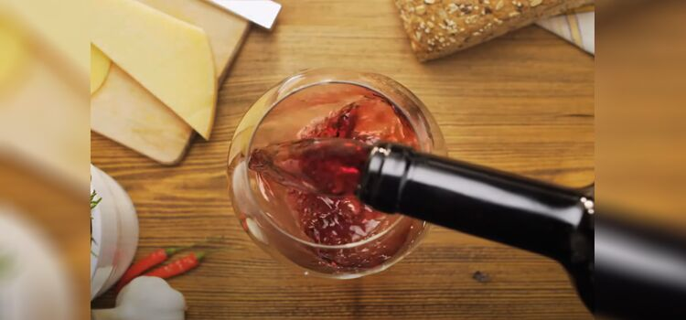
Keeping a record of the wines you try in a journal, notebook, or app can help you discover other wine candidates you may enjoy.
“I love wines, except when I’m dieting.”
— Raymond Burr, Canadian Actor
If you have tried a wine that you particularly liked, you can use that information to find other wines that are similar in style or flavor.
It will also prevent you from purchasing wines that you did not enjoy in the past.

9. Consider The Occasion & Purpose
It’s essential to consider the occasion and purpose for which the wine will be served.
For instance, if you are celebrating a special occasion such as a wedding or anniversary, you want to choose a more expensive, high-quality wine to mark the occasion.
In other cases, if you pair the wine with heavier dishes like beef or lamb, choose wine like Cabernet Sauvignon.
Similarly, if you are serving a tomato-based pasta dish, a higher-acidity wine will work.

10. Broaden Your Horizon & Try Different Variety Of Grapes
Exploring other wines beyond your usual wine preferences can expand your knowledge and appreciation of different grape varieties, regions, and styles.
If you only drink Chardonnay, you can try other white wines like Sauvignon Blanc, Riesling, or Pinot Grigio.
The point is, broadening your wine horizons can help you discover new favorites and expand your palate.

