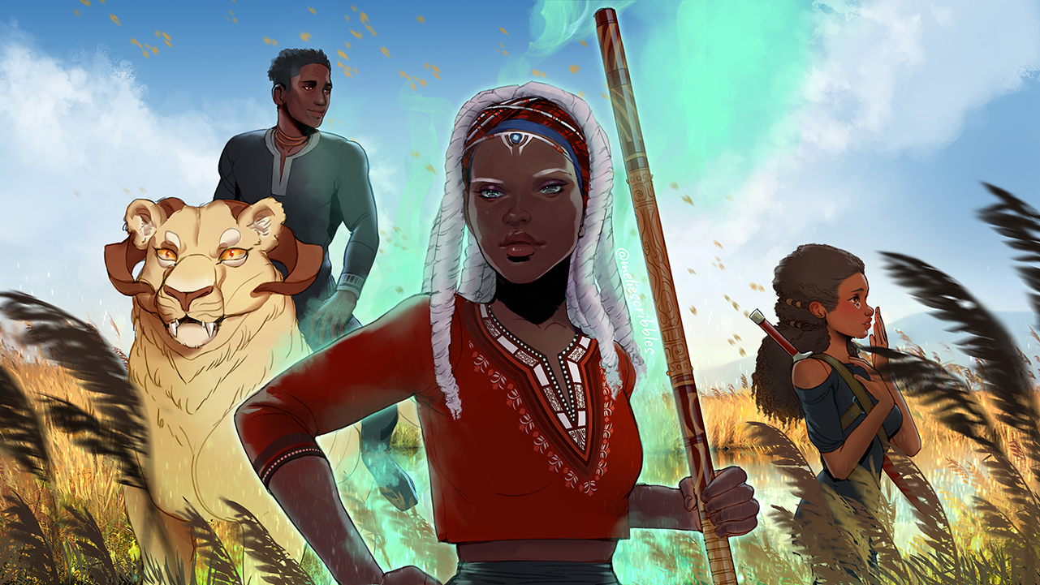
Children of Blood and Bone Paragraph
The purpose of this assignment is to not only explore your big ideas about The Children of Blood and Bone, but to also get a foundational look at paragraph writing and some of the traits of writing we will work on this year.

Prompt:
Choose one of the topics you logged this summer. In a paragraph, answer the following questions: What did you learn about this topic? What evidence (quotes) helped lead you to this understanding? Choose three significant pieces of evidence.
Elements of a Paragraph: As we work on this written piece, we will refer to this slideshow for tips on the elements of paragraph structure. Below are the specific areas of this written assignment that we will focus on:
1. Topic Sentence- The first sentence of your paragraph is the topic sentence. Your topic sentence should introduce the topic and opinion of your whole paragraph.
2. Three CLAIMS about the topics- Organize your paragraph to include enough information to support the argument in your topic sentence. You need three examples of the lessons you learned about the topic you are writing about.

3. EVIDENCE and REASONING- You must include at least 3 quotes that support the points of your paragraph. Make sure your quotes are punctuated correctly with a lead-in (no dropped quotes). And remember to provide reasoning that explains why your evidence supports your idea in the claims and topic sentence.

4. Citations- Every time you use a quote from a text, you must give the author credit with a citation in parentheses. Example: (Adeyami 55) would be an in-text citation for a quote from The Children of Blood and Bone. Remember- If you use more than one quote from the same author, you only write the author’s name for the first citation, the rest will only include the page number. Example: (57).

5. Transitions- Transitions may be a simple word or phrase that connects your points within the paragraph. The purpose of transitions is to ensure flow within your paragraph.
Examples: additionally, also, first, second, third, etc.
6. Works Cited Page- A separate works cited page includes all MLA citations used within the essay. For this paragraph, you must have a Works Cited page that includes an MLA citation for The Children of Blood and Bone. On a separate document, type Works Cited at the center of the page and include the below citation. It must be double spaced and have a hanging indent.
Example:
Last name, First name. Title of Book. City of Publication: Publisher, Year of Publication.
7. MLA Format- All your written work should have these features. Times New Roman, 12 point font, double spaced, 1 inch margins, heading, running head, works cited.

Children of Blood and Bone Paragraph Outline:
Topic Sentence:
One sentence that states what you learned about that topic.
Include the title of the book and the author.

Claim:
First lesson you learned about the topic.
Evidence:
Choose a quotation from the book that clearly shows the lesson you learned.
Reasoning:
Explain HOW the quotation proves the lesson in your claim.

Claim:
Second lesson you learned about the topic.
Evidence:
Choose a quotation from the book that clearly shows the lesson you learned.
Reasoning:
Explain HOW the quotation proves the lesson in your claim.

Claim:
Third lesson you learned about the topic.
Evidence:
Choose a quotation from the book that clearly shows the lesson you learned.
Reasoning:
Explain HOW the quotation proves the lesson in your claim.

Concluding Sentence
Paraphrase your topic sentence. Offer a concluding thought
or idea about the topic (perhaps a call to action)

Rubric:

Content | Advanced | Proficient | Needs Improvement | Points
Topic Sentence | Argument is clearly articulated and persuasive, contains an original opinion  10 9 | Thesis presents a reasonable opinion, argument is clear and focused  8 7 | Thesis is a plausible argument; contains a legitimate opinion, but somewhat broad, beginner level of analysis.  6 5
Claims and Transitions | Claims contribute to the highly persuasive nature of the argument, including a seamless transition and connection to the thesis  10 9 | Claims articulate precise argument; logically and clearly connect to thesis, and include transition  8 7 | Claims introduce what the paragraph will be about but do not include a transition or clear connection to thesis  6 5
Quote Lead-in | Quotes are skillfully integrated into the prose, providing the most relevant context  5 4.5 | Quotes are introduced with both context and an indication of who is speaking  4 3.5 | Quotes are introduced without speaker or enough context  3 2
Evidence | Best evidence used to support your point; Evidence is highly persuasive and effective in supporting your argument  10 9 | Your evidence is believable and convincing and supports your argument  8 7 | Evidence is present, but superficial or not clearly related to the point you are making.  6 5
Reasoning | Creative/original ideas and insights; extensive commentary, refreshing; goes beyond obvious and basic commentary  10 9 | Reasoning is believable and convincing, clearly connected to the claim  8 7 | Some reasoning but the connection is not elaborated upon or is not made clear.  Or no reasoning is used  6 5
Format | Essay has proper heading, margins, font, and spacing. Insightful title  5 | Has most of the proper formatting and an interesting title  4 | Missing many aspects of the formatting but not all  3 2
Grammar and Conventions | Essay is proofread well with only 1 or 2 minor errors  5 | Effective punctuation, may have a few errors but does not interfere significantly with reader’s understanding  4 | Many problems with coherence, grammar, spelling, punctuation, interfering with the reader’s understanding  3 2

Total ______/ 55

