PRACTICAL 1 - InSite Studio Overview

DURATION: 0.5 Hour
SUBJECT: Exploring InSite Studio
OBJECTIVE: Becoming familiar with the InSite Studio
MATERIALS: Your computer with a functioning version of InSite installed
REFERENCE: InSite Studio Online Help Documentation

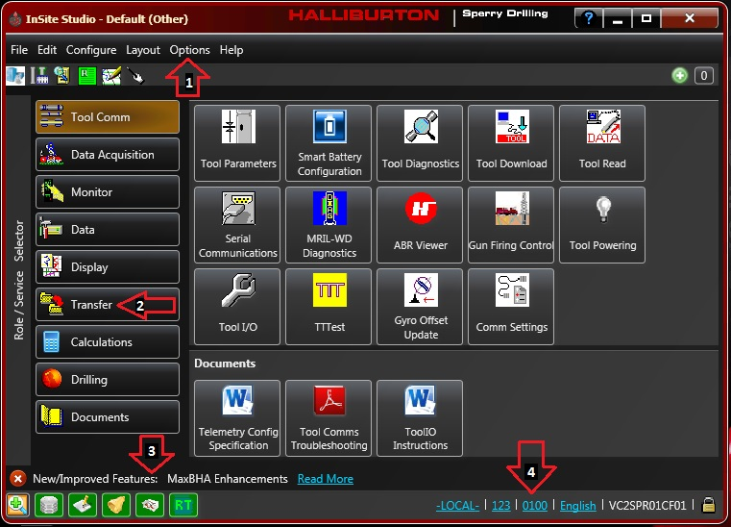

This is InSite Studio (formerly known as System Manager) for InSite. This is the primary interface for all InSite applications. Everything can be accessed and manipulated through this interface, providing you have install Full Rigsite. InSite stands for Integrated System for Information, Technology, and Engineering. InSite Studio is basically where the integration of these functions takes place.

- Beginning with the very basics, we see a row of options (Arrow 1 in figure above) at the top left of the studio. File, Edit, etc., all look very familiar; much like other computer programs. To start, we’ll cover some of the highlights. Under Configure, there are commands which allow us to select the Local Server (ADI – Applications Data Interface) to connect and run the Configuration Wizard. Another important command is located within “Help”. Click on “About InSite”. There is a lot of valuable information about InSite such as the current version of InSite your computer is running.

  - Configure has a series of commands that comprise the entire Configuration Wizard. Click Configure and note the segregated commands, Change Well/Run, Sperry Servers, Configuration Wizard and Sidetrack Wizard. To start a new (or change to an existing) well or run, select Change Well/Run or Configuration Wizard. The commands Change Well/Run and Sperry Servers are specific parts of the entire Configuration Wizard.

  - Click Configure, then Sperry Servers. This takes us to the last few pages of Configuration Wizard. Choose the telemetry type you will be running and click Next. Check the box asking if the computer will be acquiring any other surface data. In the drop-down, you can unselect, unless you are in a LWD/SDL combo unit. Click Next, then Finish.

  - Depth Tracking is controlled from Configure as well. You may go through the entire Configuration Wizard, or you can use Sperry Servers to turn on/off Depth Tracking. Again, click Configure, then Sperry Servers. Choose your telemetry type and click Next. Check the box asking if the computer will be measuring depth. This will enable the associated drop down menus. Typically, you will be selecting either Internal Depth Card (using our depth sensors, WITS or Other (getting depth through another service provider). Select Internal Depth Card and None for Real Time Drilling Options. Click Next, then Finish.

- Arrow 2 points to a wall of tabs along the left-hand side of the manager. These tabs are groups of functions, programs and data repositories. In M/LWD, we typically deal with Tool Comm, Data Acquisition, Monitor, Data, Display, Transfer, Calculations, and Documents. Click on each of these and observe how the icons change.

- Tool Comm – Programs, tests, and reads tools. There are also programs to help with tool problems/troubleshooting.

- Data Acquisition – Contains all the programs which help in acquiring data. There are four different types of telemetry that you can choose depending on the job: PPM Viewer, Manchester Viewer or EM Viewer to name a few. RT manager is also used to setup GeoSpan.

- Monitor – Calibrates and controls Depth Tracking. Under Drilling Data, we might find data. The most important icon under the Monitor tab is the Data Manager. Unit Sets is the application where units are configured for each variable. The dynamics advisor tab can be used to help mitigate vibration while drilling.

- Display – Displays the data from Data Manager. We can make logs (Plot Manager), charts (RT Charts), tables (RT Tables) and displays (RT Displays) to name a few.

- Transfer – Contains applications that allows for transfer of data. We can create text files using Exporter, receive text files using Importer, send real time data to others on the rig using WITS, and send data via satellite using Data Exchange.

- Arrow 4 points a panel of six icons. If you click on the (+) icon, the panel will maximize into the following information areas: Database, Processing, Message Log Server, Alarm and Real Time Engine. You may recall that we selected “Start Core Servers…” when we first started InSite and these icons are proof that they are indeed running as the icons are green. If there is a problem the icons will change colors to yellow or red. You will also see an additional icon that is not shown in the screen capture that will appear for Telemetry data: namely through Manchester or PPM.

- Arrow 4 points to information about the computer server operating as the ADI, active well, and active run. Here, -LOCAL- indicates that this computer is operating as the ADI. If you are connected to another computer that operates as the ADI, the computer’s Asset Tag or ID will show in place. The next box indicates which well the Active Well is. The box after that indicates the Active Run, and the last box shows your computer’s Asset Tag or ID. Summing up, the information found under Arrow 4 is a quick way to identify which computer is operating as the ADI, and which well and run are active at the moment.

