PRACTICAL 1

SUBJECT: InSite Software

OBJECTIVE: Uninstall / Install InSite Software and Upgrades

MATERIALS: Current Versions of InSite and Associated Patches

REFERENCE: InSite Field Release Notes, located with the install software

Part I – Uninstall InSite

NOTE: Before beginning, ensure that all ADIs have been backed up to another location as they will be removed during the following process.

Uninstall InSite from your computer. Go to the Start Menu and select All Programs. Find the INSITE folder and select Uninstall InSite from within. After the program has run, restart your computer.

NOTE: NEVER remove InSite using the Programs and Features function of the Control Panel. Also NEVER just delete the INSITE and ADI folders as this will make the computer unable to remove or add InSite and the computer will probably need to be re-imaged to fix this issue.

Verify that InSite has been removed. Check the C: drive to ensure that the INSITE folder and all of its sub-folders have been removed.

Delete the ADI folder. The ADI directory containing the database should still be visible in the C: drive. Delete this folder and the uninstall process is complete.

Part II – Install InSite

NOTE: Hardware Requirements. Like any software, InSite is built to perform on certain Operating System Platforms.

Find and run the .exe file to install the core version. A series of prompts will pop up – click yes / agree etc. where appropriate. When the following pop up appears, make sure that Full Rigsite is selected and un-check the box for Auto Start InSite.

NOTE: the Full Rigsite version allows for data manipulation. For computers that should only be able to display data (i.e. Rig Floor, Co Man, etc.), Basic Rigsite Plus should be used.

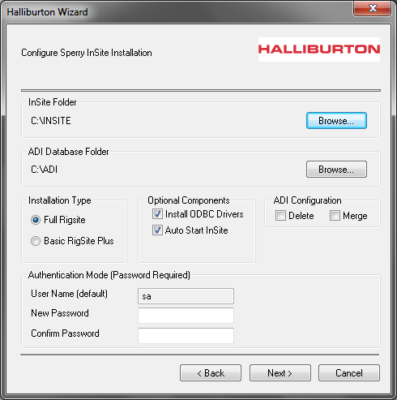

This box will always be checked by default. You must uncheck it.

Figure 1.1

After the file has been run, InSite Configuration Options will pop up. Click OK.

The Halliburton Wizard will now pop up signifying that the install is complete. Make sure the button to Restart your computer is selected and click Finish.

Go through the same process with any additional updates or patches. When finished with each one, always select Restart before clicking Finish.

Part III – License & Initial Configuration

InSite will not run without a valid license. Licenses are machine specific (they are tied to your computer’s MAC address) and are only good for a specific time period. When a copy of InSite is ordered, a matching license is included. This license MUST be placed in the proper folder for InSite to operate. Its location is as follows: C: / Program Files (x86) / Halliburton / LAM. Simply drag the license into this folder and InSite will be able to start.

Double click the InSite Studio icon on your desktop to start InSite. Upon startup, InSite will ask whether you want to start the Core Servers on your machine. Having the core servers running on your machine means that it is the ADI (Applications Data Interface). Click Next.

NOTE: If you do not go through with this initial configuration, your database will become corrupted.
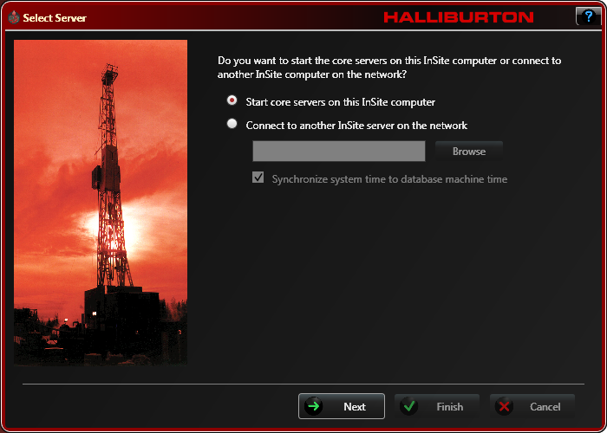
Figure 1.2

The next page will ask for a Well ID and Run. Since we are starting InSite for the first time, it is suggested to create a dummy well and run. Something such as Test for the well ID and 0100 for the run number are acceptable. Fill in this information and click Next.

The next page is called Automatic Descriptor Update Selection. If you leave all of these boxes checked (recommended), InSite will automatically update all of these descriptors (more on descriptors later). Click Next.

Select SDL and Logging under Services Configuration Options. Click Next.

This page is very important. Here, we can select whether we will be tracking depth, acquiring surface data and whether the Hydraulics server will be running. You will also notice check boxes for CVE/EAGLE and DGD. Leave all of these boxes unchecked for now; we will be learning about the uses of each of these later. Click Next – you will be prompted that the configuration is complete. Click Finish. This procedure is complete.

Part IV – Time Considerations

This is not technically part of InSite, but can have a significant impact on data collected by InSite. In some parts of the world, Daylight Savings Time is observed. This means that two times every year, the time shifts either forward or backward one hour.

How can this affect InSite? InSite time stamps data based on the computer clock. If the computer clock shifts back one hour in the Fall, any data collected in the hour previous will be overwritten with the new data. Conversely, a time shift forward in the Spring will leave a gap of one hour and it will appear that no data was collected.

Either scenario is undesirable; how do we control this situation? You have to go into the Time Zone Settings on your computer and make sure the Automatically Adjust Clock for Daylight Saving Time box is unchecked (See Figure 1.3). Time changes can be made after Runs have been completed.
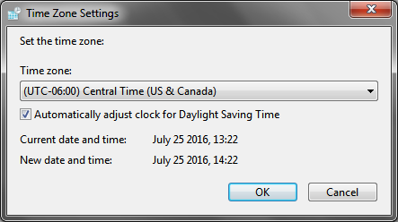
Figure 1.3

NOTE: DO NOT load any unauthorized software on computers loaded with InSite. Occasionally, software will have a duplicate named executable file and will overwrite the InSite file. Also, please be patient while InSite is working. Some screens will tend to load slowly and clicking the screen while the program is working will often cause InSite to stop running properly.

