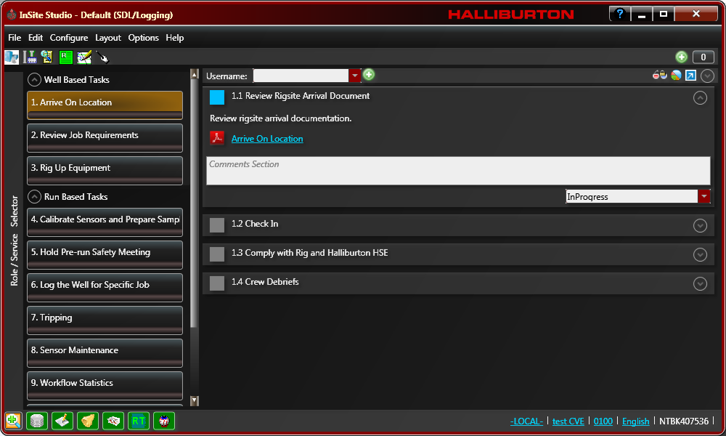
SDL Fundamentals: Data Engineer
Course Workbook

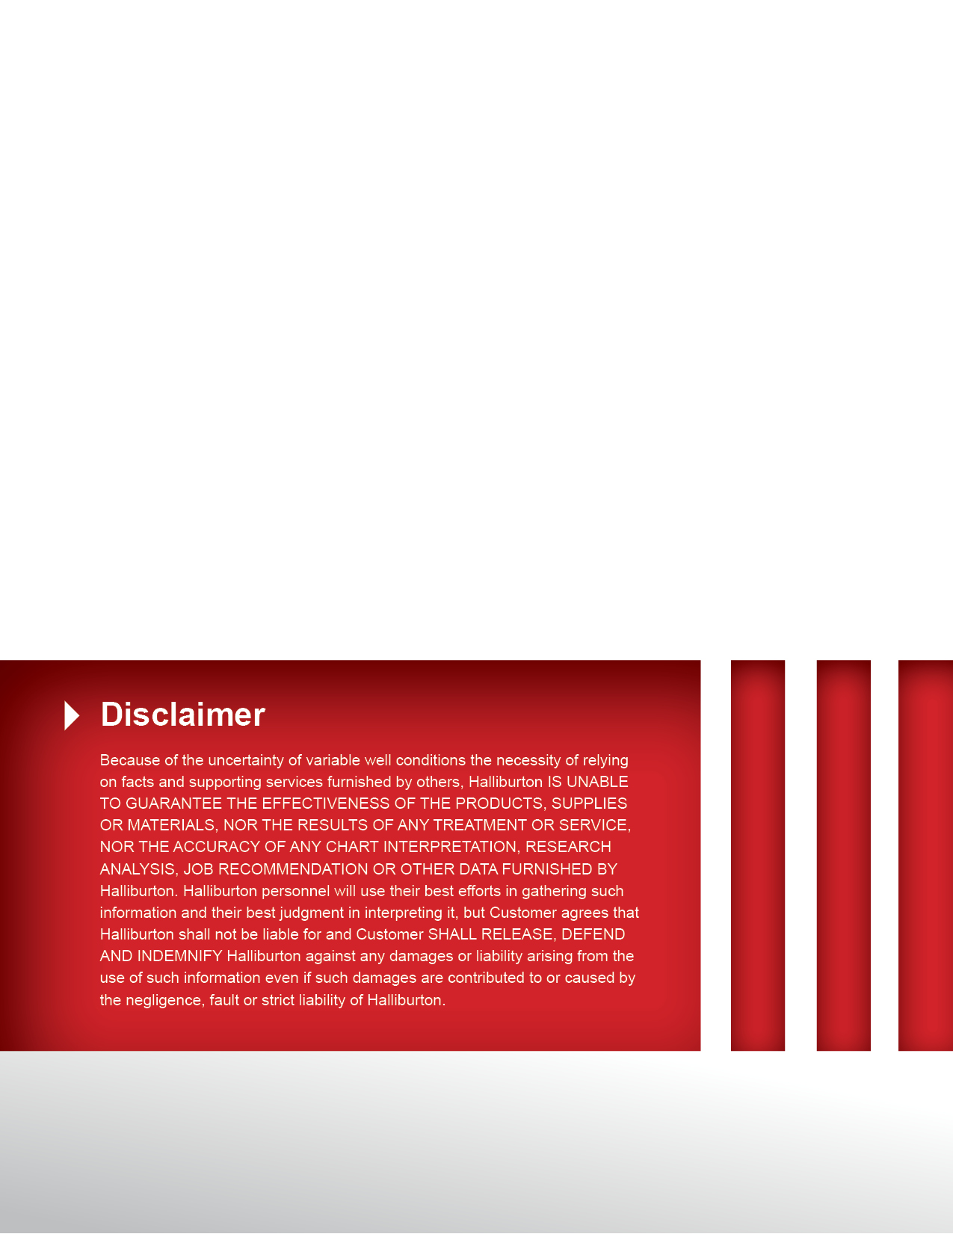
Table of Contents
Practical 1: Overrides
4

7

11

18

25

27

29

38

41

Practical 2: Geometry

Practical 3: Creating Custom Variables

Practical 4: Transferring Data

Practical 5: Real-time Operations Log

Practical 6: 1” Measured Depth Engineering Log

Practical 7: Other Types of Displays

Practical 8: Alarms

Practical 9: Hydraulics

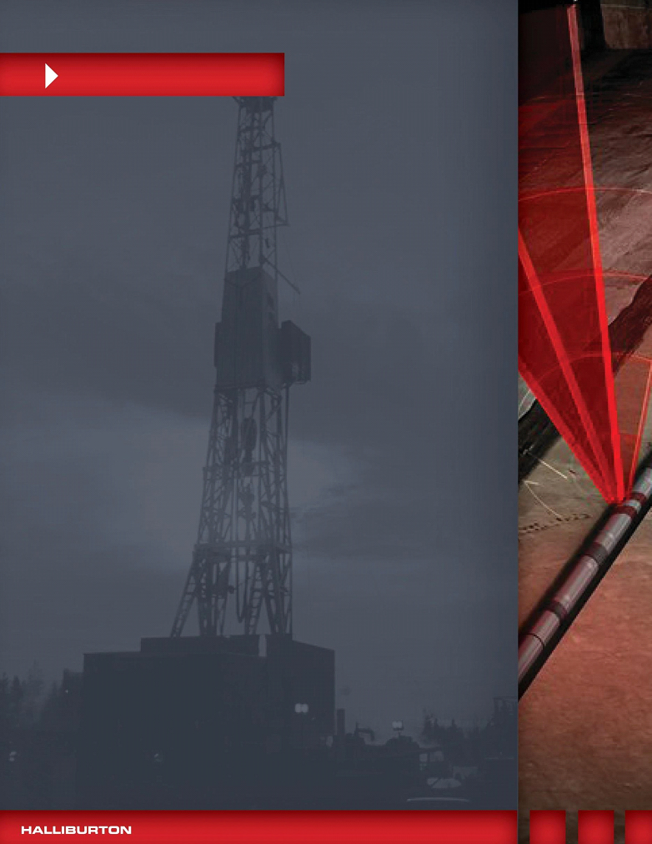

Practical 1

SUBJECT: Overrides

OBJECTIVE: Overriding Variables using IRIS Overrides

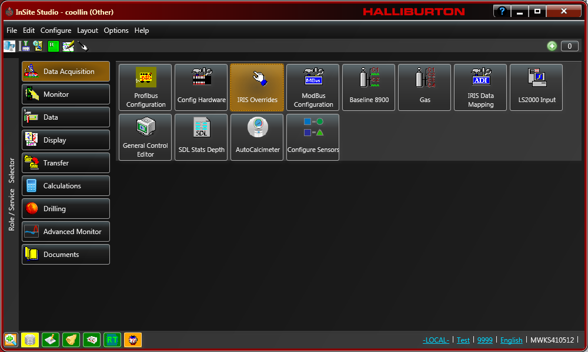
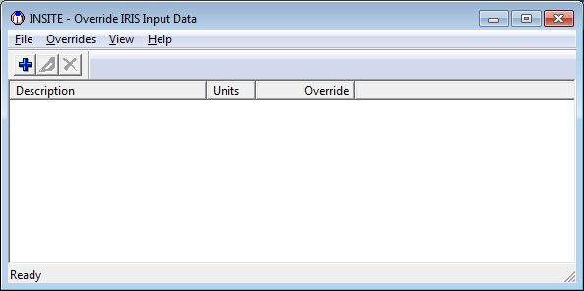
IRIS has a function to override the real time parameters. From InSite Studio, select the Data Acquisition tab and then click on the IRIS Overrides button. The IRIS Override Screen will appear.
Figure 1.1

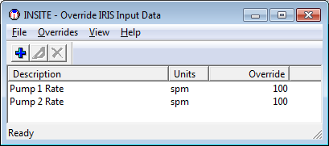
Figure 1.2

In this example, the pump rates on Pumps 1 and 2 have been overridden with 100 strokes apiece.

To add an override to IRIS, click on the + sign or, from the drop down under Overrides, select add.

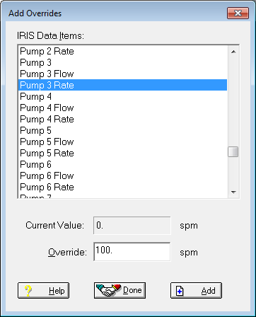
Select the parameter to override, in this case Pump Rate 3, and input a value. The current value for the selected parameter is also displayed. Click on Add and then Done to make the change take effect.
Figure 1.3

To edit an existing override, highlight it in the IRIS Overrides window and click on the Edit icon (the pen nib). To delete an override, highlight it and click on the X to delete it.

The same above steps can be used for any IRIS parameters as Pore Pressure Estimated, MW……etc. See below.

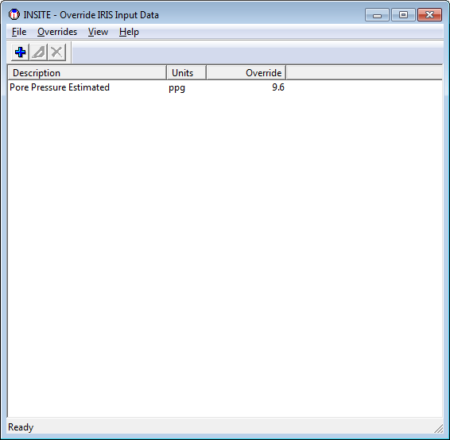
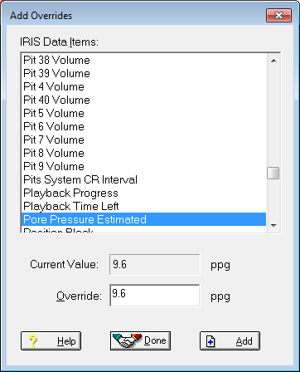
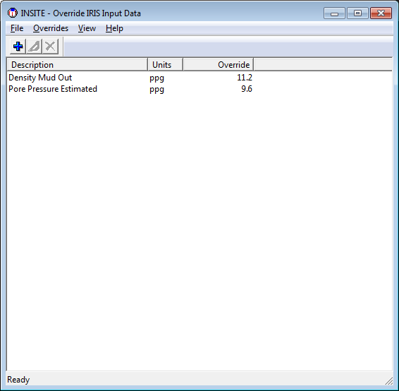
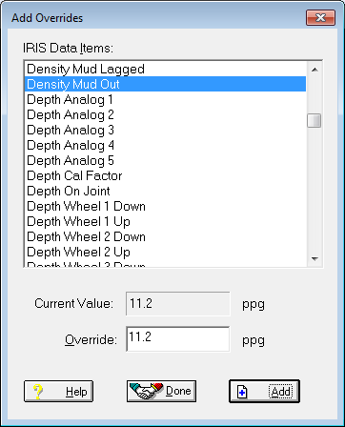
Figure 1.4

The Override IRIS Input Data screen will show added overrides displaying each variable added with the units sets used and the override value, as seen in Figure 1.5.

Create the following overrides as displayed in Figure 1.5 and take a screen capture to include in a word document.

Describe a circumstance where you might use an override not including the overrides used in the practical exercise. Save this document as Your Name Overrides. Send this via email to the instructor.

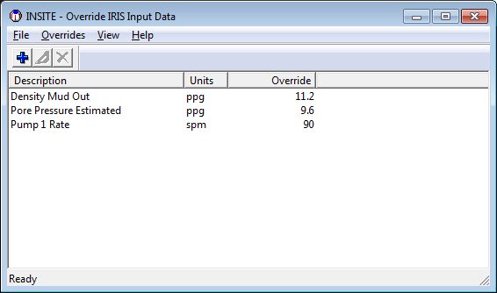
Figure 1.5

